ApiGateway, Lambda, DynamoDB task

Description

In this module we will take a look on ApiGateway, take a look on Serverless computing and try some things with NoSQL Serverless Native DynamoDB.
Diagram

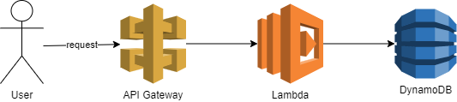

Homework

At the end of this homework you need to have:
API Gateway with two endpoints to upload information about your products (id, name, pictureURL, price) and to update information
Lambda that processes that upload (check if data is already present in DynamoDB and put it if it is not present)
Lambda that processes information updates
DynamoDB with 1 Table with products information

Create DynamoDB table for products info (be sure to read) :
NOTE: product is some simple model with name, price and picture_url
20 points
Implement Lambda that processes uploading information about products from request body (be sure, that lambda uses assume role instead of raw credentials to access DynamoDB):
20 points
Implement Lambda that processes updating information about products (be sure, that lambda uses assume role instead of raw credentials to access DynamoDB):
20 points
Create API gateway and configure endpoints:
20 points
Implement small console application with generated API gateway sdk (link) to create and update information:
20 points

Extra mile:
Implement simple js application with generated API gateway sdk for uploading information – 40 points
Total mark is 100. 100 points for regular homework and 40 points for extra mile.

